**Testing**

1. User registering and login

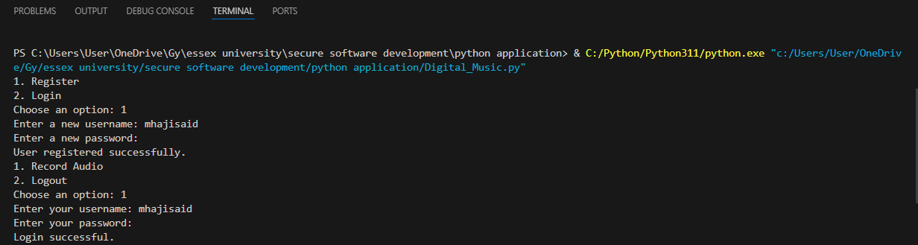

1. Music recording

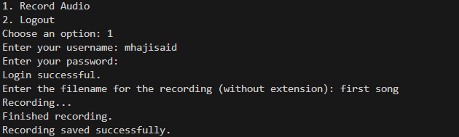

1. View recordings and ratings then logout

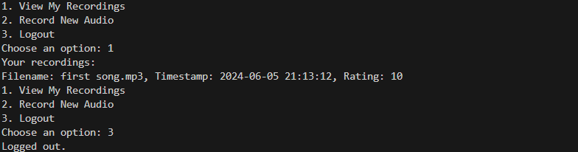

1. Recording table on the database

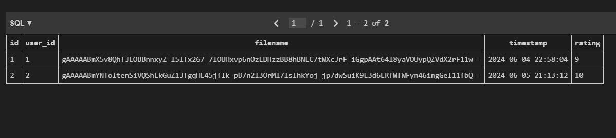

1. User table on the database

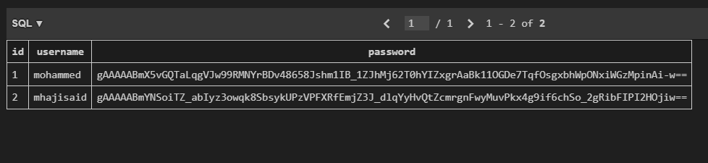

1. Admin login

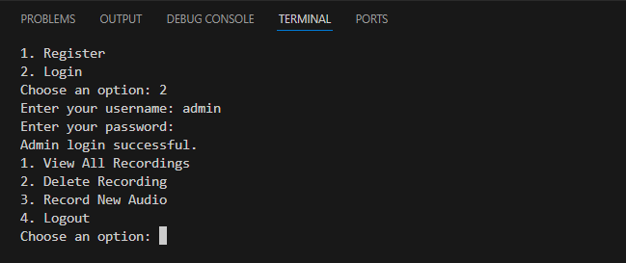

1. Admin view all recording

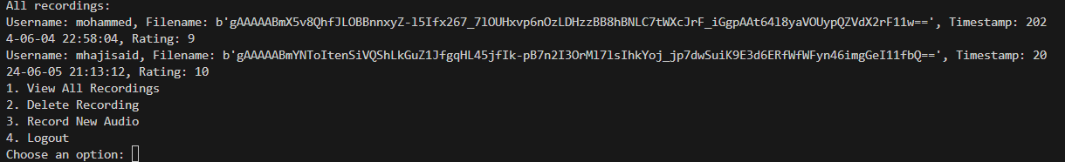

1. Admin delete recording and view remaining recordings

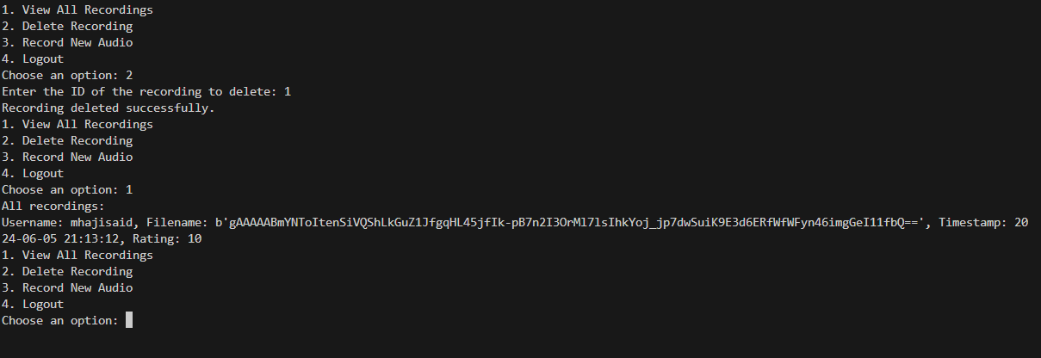

1. Admin record track

